DAY OF SOLIDARITY WITH
PALESTINIAN RESISTANCE
(Rally & March)

Zionist Occupation Continues
Hundreds of Palestinian Homes Demolished
Thousands of Palestinians Killed & Injured
Tens of Thousands of Olive Trees Uprooted
Palestinian Resistance Strengthens!!
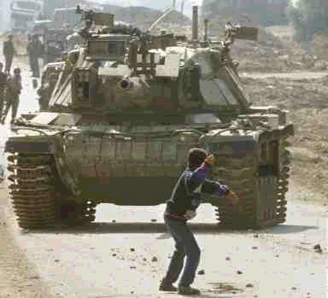
Support the Resilience of the Intifada
Wednesday November 29th, 2000

2ND AVE Between 42 and 43 Streets (NYC)

Rally: 4-6 PM

March: 6-7PM
SPONSORED by Al-AWDA, Palestine Right of Return Coalition
ENDORSMENTS: The International Action Center, The Committee for Palestine, The Arab Communications Committee, CESR, ADC, Council on American Islamic Relations,
Palestine Aid Society, Middle East Children’s Alliance, The Arab/American Progressive
Movement of Westchester, AAI, The Vieques Support Campaign.

