Ever wonder what it is like to be a refugee?

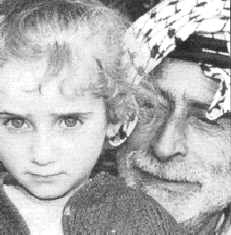

Or how it feels to be shot by a rubber bullet?
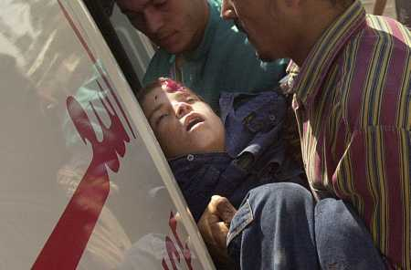
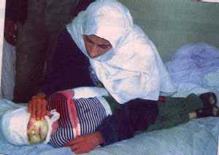

Monday, Dec. 4th @ 5:15pm in Alumni Hall A

The NYUMC Muslim Students’ Association commemorates the start of Ramadan by hosting a guest lecture focusing on the living conditions of Palestinian refugees, the effects of controversial “rubber” bullets used by Israeli forces and a brief introduction of the events leading to the creation of the world’s largest refugee population.

Fast Break will be promptly at 4:31 PM. Prayer will follow for those interested.

Lecture will begin at 5:15PM. All are welcomed and encouraged to attend. Refreshments will be provided. Contact nyumedmsa@yahoo.com for more info. NYUMed is located at 550 First Avenue(bet. 30 and 34th st.). Nearest train stop is 33rd st. on the 6 line.

