TURATH
presents

Artists for Palestine
A benefit to provide medical aid for
Palestinians injured in the recent violence

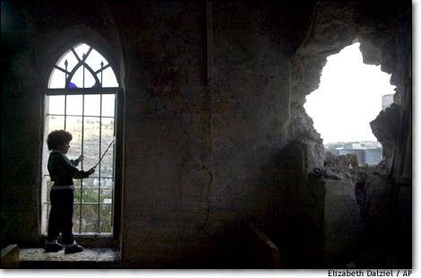

November 1, 2000 @ 7:30 PM
Columbia University, 115th Street & Broadway
Arledge Auditorium, Lerner Hall

featuring:

Simon Shaheen
Musician
Ammiel Alcalay
author, After Jews and Arabs
Joe Sacco
comic artist, author of Palestine and Stories from Bosnia

and Poetry by:
Hayan Charara · Suheir Hammad · Annemarie Jacir · D.H. Melhem
Oz Shelach · Meroe Elahi · Zahera Saed · Ishle Park
Ahimsa Bodhran · Betty Shamieh · Jim Rizkalla

Special musical appearance by Takht

Middle Eastern food will be served. Sliding Scale Admission: $5/$10/$15
Co-sponsors: Organization of Pakistani Students, Center for Economic and Social Rights, Middle East Children’s Alliance, Art Action, Al-Awda, Radius of Arab American Writers

http://www.columbia.edu/cu/turath

