OH LITTLE TOWN OF BETHLEHEM
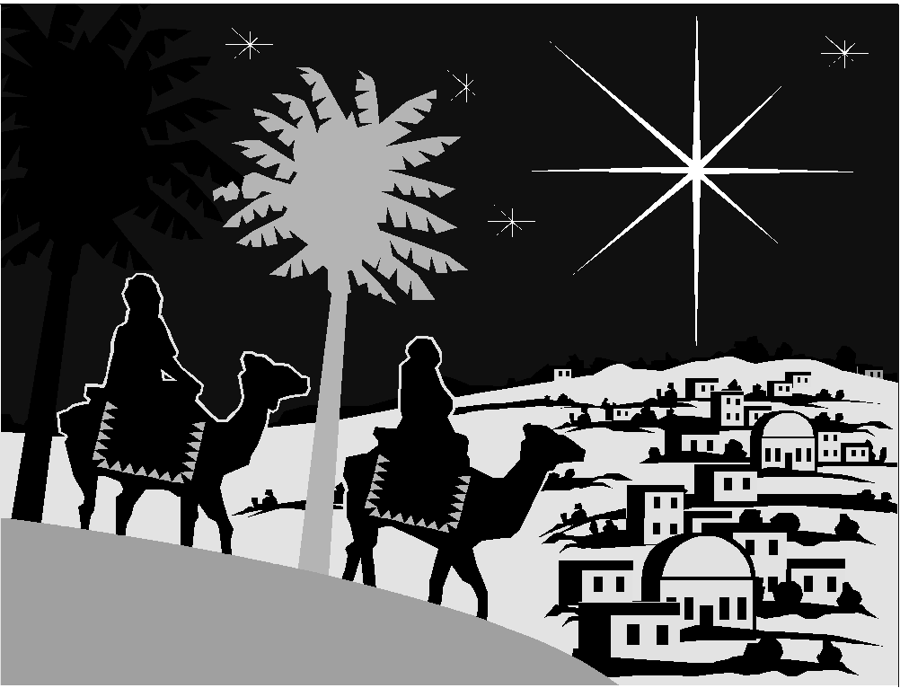
THIS CHRISTMAS SEASON THE CITY OF BETHLEHEM IS BEING BOMBED BY THE STATE OF ISRAEL
TO DATE: Over 300 people have been killed and Over 8,000 injured

“I have been shocked, dismayed and disturbed by what I have seen and heard…The statistics have their own story.” - Mary Robinson, UN High Commissioner for Human Rights on her visit to the Occupied Territories. 11/15/00

Gross Human Rights Violations in Bethlehem and the surrounding areas of the West Bank and the Gaza Strip include:
*Frequent shelling from tanks and helicopters on towns and refugee camps, resulting in hundreds of families losing their homes.
*Attacks on Palestinian farmers, schoolchildren, journalists, ambulances, and medical personnel by armed Israeli settlers.
*Communities under 70 consecutive days of military curfew which prevents the entrance and exit of goods and medical services and prevents people from working.
*Destruction of Palestinian farmland and houses by the Israeli Army
*Mass arrests and torture
(Source:www.amnesty.org, www.infopal.org, www.lawsociety.org)

What can we do about this?
Write to your policymakers:
1. Demand an end to US military aid: Israel is the largest recipient of US foreign aid, and their weapons used against Palestinian civilians are financed by and sent from the US, including a large transfer of helicopter gunships last month.
2. Demand Israel’s immediate withdrawal from the occupied territories, in compliance with international law and UN Resolutions 242, 338, and 1322.
Get informed: Get the information the US media isn't giving you.
Breaking News: www.addameer.org/September2000/
International Law and Human Rights Violations: www.law society.org
Middle East Conflict Primer: www.merip.org
Peace Process Facts and Analysis: www.cesr.org
AL-AWDA /PALESTINE RIGHT TO RETURN COALITION
ARAB AMERICAN PROGRESSIVE MOVEMENT (WESTCHESTER)

