Al-awda and Alternate Focus

first Annual Video Contest
This is a worldwide contest devoted to adding voice to the Palestinian people

www.al-awdacal.org www.alternatefocus.org

Submission Due Date
September, 15 2005



Al-Awda and Alternate Focus are dedicated to amplifying the unheard voice of the Palestinian people to the American public.

Take this opportunity to be broadcast on television and distributed on DVD’s worldwide.

We will be awarding a cash prize to the finalists.

A panel of Al-Awda and Alternate Focus judges will view all submissions.

Al-Awda and Alternate focus reserve the rights to all tapes submitted for the video contest.

The UN General Assembly set forth the framework for resolving the Palestinian refugee case in UN Resolution 194 (III) which provides only two solutions: repatriation for those refugees "wishing to return to their homes and live in peace with their neighbors," or compensation for those choosing not to return
According to international law, refugees have the right to return to their homes of origin, receive real property restitution, and compensation for losses and damages.
Of the 3.8 million refugees registered with the United Nations Relief and Works Agency (UNRWA), 33% live inside UNRWA's 59 refugee camps throughout the West Bank and Gaza Strip, Jordan, Syria and Lebanon.
Israel continues to reject UN Resolution 194 as a basis for discussion in final-status negotiations, saying that the 'right of return' is incompatible with Israel's right of self-determination.

~ Some suggested subject categories ~

The Right of Return
History of Palestine
Culture (modern or past)
Current Events
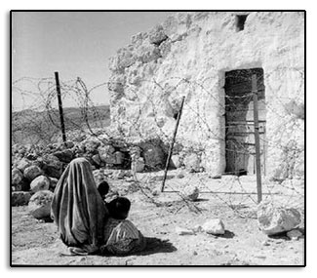
Here are refugees barricaded from their homes.

In November 1947, the United Nations General Assembly passed Resolution 181, endorsing the partition of Palestine. War ensued and resulted in the imposition of the colonial state of Israel on 77% of the total area of historic Palestine. Over 750,000 Palestinians were displaced and dispossessed from their homes and land, creating what has become the largest refugee population in the world. Palestinian facilities and private properties such as schools, hospitals, houses and lands confiscated by the Israeli government as “state property” since 1948 have been allocated for use by Jews only. New Jewish only settlements/colonies throughout Palestine (present-day Israel, the West Bank and Gaza Strip) are built on the remains of destroyed Palestinian villages and on land which belongs to Palestinians.

Al-Awda and Alternate Focus
Video Contest Form
Title of film____________________
Running time__________________
Contact information:
Name_________________________
Address_______________________
______________________________
Email address__________________
Phone number_________________
Signature_____________________
Please detach this form and return it
with your video submission to:
Al-Awda and Alternate Focus Video Contest
8439 Paseo Del Ocaso
La Jolla, Ca 92037

Submission Due Date
September, 15 2005

www.al-awdacal.org
www.alternatefocus.org

All tape formats are acceptable.
Thank you and good luck!
Al-Awda and Alternate focus reserve the right to all submissions. Submissions cannot be returned.

